ENGINEERING PROJECT DESIGN PROPOSAL
Title of Project:
[Insert Specific and Descriptive Title]

Student Name: [Your Name]
Student Number: [Your Student Number]
Supervisor: Dr M.S Nkambule & Mr S.T Leholo
Department: Computer Systems Engineering
Module Code: EGD107V
Institution: Tshwane University of Technology
Date: [Insert Date]

Contents

- Introduction / Background 4
- Problem Statement 4
- Research Questions / Hypothesis 4
- Key Variables 4
Independent Variables (What you change): 4
Dependent Variables (What you measure): 5
Establishing Relationships 5
Questions : 5
  - How can a centralised digital system improve patient referral tracking in healthcare facilities? 5
  - What impact does real-time referral tracking have on reducing delays in patient care? 5
  - How can artificial intelligence improve user interaction and system efficiency? 5
  - What are the benefits of integrating patient records and referral systems into one platform? 5
- Aim and Objectives 5
- How can a centralised digital system improve patient referral tracking in healthcare facilities? 6
- What impact does real-time referral tracking have on reducing delays in patient care? 6
- How can artificial intelligence improve user interaction and system efficiency? 7
- What are the benefits of integrating patient records and referral systems into one platform? 7
- Contribution & Innovation 8
- Literature Review 8
6.1 Introduction 8
6.2 Electronic Health Records (EHRs) and Digital Health Systems 9
6.3 Patient Referral Systems in Healthcare 9
6.4 Integration of Patient Records and Referral Systems 9
6.5 Cloud Computing in Healthcare 10
6.6 Artificial Intelligence in Healthcare Systems 10
6.7 Challenges in Resource-Constrained Environments 11
6.8 Identified Research Gap 11
6.9 Conclusion of Literature Review 12
- Research Methodology 12
Modeling/Design : 12
Tools & Technologies: 12
Data Collection 12
Validation: 13
- System Design / Architecture 13
- Significance and Expected Outcomes 15
9.1 Significance of the Research 15
9.2 Performance Improvement 15
9.3 Expected Deliverables (Prototype / Model) 15
The prototype will include: 15
9.4 Validation of the Prototype 16
9.5 Industry and Societal Impact 16
- Project Plan and Timeline 16
- Budget Estimate 17
- Delimitations & Limitations 18
Delimitations: 18
Limitations: 18
- Risk Assessment 18
- Conclusion 18
- References 18

- Introduction / Background

The healthcare sector s increasingly adapting the digital technologies to improve efficiency, data accessibility and patient outcomes. In developed healthcare systems, integrated Electronic Healthcare Record (EHR) systems and referral management platforms enable seamless communication between healthcare providers. However, in many developed countries such as South Africa, particularly in rural and under-resourced areas healthcare systems still face significant challenges related to data management and patient coordination.
Currently, many public healthcare facilities rely on fragmented systems and paper-based records. These methods are inefficient, prone to data loss, and limit the ability to share patient information across facilities. Although structured referral frameworks exist, their implementation is inconsistent due to lack of infrastructure and integration between systems.
A major gap exists between formal healthcare processes and the tools used in practice. Healthcare workers often resort to informal communication platforms such as WhatsApp to coordinate referrals, which lack security, traceability, and centralised data storage. This highlights the need for a unified, secure and scalable digital solution that integrates patient record management with referral tracking.
This system would improve communication enhance efficiency, and support better patient care, making it highly relevant to the healthcare industry.
- Problem Statement

The South African public healthcare system lacks an integrated and secure digital platform for managing patient referrals and records. This results in inefficient coordination between healthcare facilities, delayed patient care, and increased risk of data loss. Current systems are either paper-based or fragmented, leading to duplication of records and limited data accessibility. Informal communication tools, while convenient, do not provide accountability, traceability, or data security. There is also a challenge due to the implementation of different EHR systems from various vendors, as these systems are built with different underlying database architectures and therefore often fail to communicate and share information among each other. The absence of a centralised system creates measurable inefficiencies, including increased referral processing time, reduced data accuracy, and poor communication between healthcare providers.
- Research Questions / Hypothesis
Hypothesis: The implementation of a centralised, cloud-based referral system will significantly reduce referral delays and improve system efficiency compared to traditional paper-based and fragmented systems.

Key Variables

Independent Variables (What you change):
- Implementation of a centralised digital system
- Use of real-time referral tracking
- Integration of an AI chatbot interface
- Use of cloud-based infrastructure

Dependent Variables (What you measure):
- Referral processing time
- System efficiency (task completion time)
- User satisfaction/usability
- Data accuracy and accessibility
- Reduction in lost or delayed referrals

Establishing Relationships
- A centralised digital system is expected to reduce referral processing time and improve coordination.
- Real-time tracking is expected to reduce delays and improve accountability.
- AI chatbot interaction is expected to improve usability and reduce administrative workload.
- Cloud-based infrastructure is expected to improve scalability and system availability.

Questions :
  - How can a centralised digital system improve patient referral tracking in healthcare facilities?
  - What impact does real-time referral tracking have on reducing delays in patient care?
  - How can artificial intelligence improve user interaction and system efficiency?
  - What are the benefits of integrating patient records and referral systems into one platform?

  - Can a cloud-based system provide a scalable and cost-effective solution for resource-constrained environments?

- Aim and Objectives

Aim
To design, develop, and evaluate a cloud-based digital healthcare system that improves patient referral tracking, enhances data accessibility, and reduces delays in patient care within resource-constrained environments.
- Design and Develop the System
To design and implement a centralised web-based system that integrates patient record management, referral tracking, and an AI chatbot using cloud infrastructure.

2. Implement Real-Time Referral Tracking
To develop and integrate a real-time referral tracking module that allows healthcare providers to create, monitor, and update referrals efficiently.

3. Analyse System Performance
To evaluate the system’s performance by measuring key metrics such as referral processing time, system response time, and task completion efficiency.

4. Evaluate AI Chatbot Effectiveness
To assess the usability and effectiveness of the AI chatbot in improving user interaction and reducing administrative workload.

5. Validate System Scalability and Feasibility
To validate the scalability, reliability, and cost-effectiveness of the cloud-based system in a simulated resource-constrained environment.

Research Q & A :
- How can a centralised digital system improve patient referral tracking in healthcare facilities?
A centralised digital system improves patient referral tracking by enabling real-time data sharing, standardised communication, and improved coordination between healthcare providers. In traditional systems, referrals often rely on paper-based processes or fragmented systems, leading to lost information and poor follow-up.
Centralised systems, particularly those based on Electronic Health Records (EHRs), allow both referring and receiving providers to access the same patient information instantly, improving communication and continuity of care. This reduces duplication of records and ensures that all stakeholders have visibility into the referral process.
Additionally, centralised systems enable structured workflows and referral status tracking, ensuring that referrals are not lost and that follow-ups are completed. Studies show that electronic referrals improve coordination by allowing providers to exchange information electronically and access complete patient records in one place.
- What impact does real-time referral tracking have on reducing delays in patient care?
Real-time referral tracking significantly reduces delays by providing continuous visibility into the status of referrals. In traditional systems, delays often occur due to lack of feedback, lost paperwork, or unclear communication between providers.
With real-time tracking, healthcare professionals can monitor whether a referral has been received, approved, or completed, allowing them to take immediate action if delays occur. This improves accountability and ensures timely intervention.
Research indicates that integrating referral status tracking and feedback mechanisms into healthcare workflows helps “close the communication loop,” ensuring that providers are aware of referral outcomes and reducing inefficiencies.
Furthermore, electronic referral systems have been shown to reduce wait times and improve workflow efficiency, directly contributing to faster patient care.
- How can artificial intelligence improve user interaction and system efficiency?
Artificial intelligence (AI), particularly through Natural Language Processing (NLP), enhances user interaction by allowing healthcare professionals to interact with systems using natural language instead of complex interfaces. This reduces the learning curve and improves usability.
AI can automate repetitive administrative tasks such as:
  - Retrieving patient records
  - Auto-populating referral forms
  - Extracting relevant clinical information
This reduces cognitive workload and improves efficiency. Research shows that automation in digital health systems can decrease workload and streamline referral processes.
Additionally, AI techniques such as NLP enable the extraction and processing of unstructured medical data, improving data accessibility and decision-making.
Overall, AI improves both user experience and system performance by reducing manual effort and enabling faster interactions.
- What are the benefits of integrating patient records and referral systems into one platform?
Integrating patient records and referral systems into a single platform provides several key benefits:
    - Improved data accessibility: Healthcare providers can access complete patient information without switching systems
    - Better coordination of care: All stakeholders share a unified view of patient data
    - Reduced duplication: Eliminates repeated data entry and inconsistencies
    - Enhanced decision-making: Providers have access to comprehensive patient history
An integrated system allows providers to exchange information electronically and access the entire patient record, which improves coordination and referral success.
It also supports more efficient workflows, as relevant patient data can be automatically included in referrals, reducing administrative burden and errors.
    - Can a cloud-based system provide a scalable and cost-effective solution for resource-constrained environments?
Yes, cloud-based systems are widely recognized as scalable and cost-effective solutions, particularly for resource-constrained environments.
Cloud computing eliminates the need for expensive on-site infrastructure, allowing healthcare facilities to access systems via the internet with minimal hardware requirements. This makes it ideal for rural or under-resourced settings.
Additionally, cloud systems offer:
    - Scalability: Resources can be increased or decreased based on demand
    - Cost efficiency: Pay-as-you-go pricing reduces upfront costs
    - Reliability: Managed services ensure high availability and data backup
Studies on electronic referral systems highlight their economic and operational benefits, including improved efficiency and reduced costs.
Therefore, cloud-based solutions align well with the needs of developing healthcare systems by providing flexible, affordable, and sustainable infrastructure.

- Contribution & Innovation
- Integration of patient records and referral tracking in a single platform
- Use of AI chatbot for natural language interaction
- Cloud-based architecture for scalability and accessibility
- Replacement of informal communication tools with a structured system
- Improved accountability and real-time tracking of referrals

- Literature Review

6.1 Introduction
The integration of digital technologies into healthcare systems has become increasingly important in improving efficiency, accuracy, and patient outcomes. Healthcare systems worldwide are transitioning from traditional paper-based processes to electronic systems that enable better data management and communication. However, in developing countries such as South Africa, particularly in resource-constrained and rural environments, this transition remains incomplete.
One of the key challenges in such environments is the management of patient referrals and records. Effective referral systems are essential for ensuring continuity of care, especially in multi-level healthcare systems where patients move between primary, secondary, and tertiary facilities. This literature review explores existing research on electronic health records, referral systems, cloud computing, and artificial intelligence, highlighting gaps that justify the need for the proposed system.

6.2 Electronic Health Records (EHRs) and Digital Health Systems
Electronic Health Records (EHRs) are digital versions of patients’ medical histories that can be accessed and shared across healthcare providers. EHR systems are widely recognized for improving the quality of care by enabling real-time access to patient data, reducing duplication, and supporting informed decision-making.
According to the World Health Organization, digital health systems play a critical role in strengthening healthcare delivery by improving data accessibility and supporting coordinated care. EHR systems enable healthcare professionals to retrieve patient information quickly, which is particularly important in emergency and referral situations.
Despite these advantages, many healthcare facilities in developing regions continue to rely on paper-based systems or partially implemented digital systems. These systems often lack interoperability, meaning they cannot communicate effectively with other systems. As a result, patient data remains fragmented across multiple platforms, limiting its usefulness.
Research indicates that while EHR adoption improves efficiency, its benefits are maximized when systems are integrated across facilities. Without integration, EHR systems fail to support seamless referral processes, leading to delays and inefficiencies.

6.3 Patient Referral Systems in Healthcare
Patient referral systems are a critical component of healthcare delivery, ensuring that patients receive appropriate care at the correct level of the healthcare system. Effective referral systems facilitate communication between healthcare providers and ensure continuity of care.
Traditional referral systems often rely on paper-based forms, which are prone to loss, delays, and incomplete information. Studies have shown that these inefficiencies contribute to longer waiting times and reduced quality of care. Electronic referral (e-referral) systems have been introduced to address these challenges by digitizing the referral process.
Research by Hysong et al. demonstrates that electronic referral systems improve coordination by enabling providers to exchange information electronically and track referral progress. These systems provide visibility into referral status, ensuring that referrals are completed and followed up appropriately.
However, the implementation of e-referral systems is often limited by infrastructure constraints, lack of training, and resistance to change. In many cases, healthcare workers resort to informal communication tools such as messaging applications, which do not provide structured data management or security.
This highlights the need for a system that combines the benefits of digital referrals with usability and accessibility tailored to resource-constrained environments.

6.4 Integration of Patient Records and Referral Systems
One of the major limitations identified in existing healthcare systems is the lack of integration between patient records and referral systems. In many cases, these systems operate independently, requiring healthcare providers to manually transfer information between platforms.
Integrated systems provide a unified platform where patient records and referrals are managed together. This integration offers several advantages, including improved data consistency, reduced duplication, and enhanced communication between providers.
Research indicates that integrated systems significantly improve workflow efficiency by allowing patient data to be automatically included in referral processes. This reduces administrative burden and minimizes errors associated with manual data entry.
Furthermore, integration supports better decision-making, as healthcare providers have access to complete patient histories when making referral decisions. This is particularly important in complex cases where accurate and comprehensive information is required.
Despite these benefits, integration remains a challenge in many healthcare systems due to technical and organizational barriers. This creates an opportunity for innovative solutions that prioritize interoperability and ease of use.

6.5 Cloud Computing in Healthcare
Cloud computing has emerged as a powerful tool for addressing the challenges associated with traditional healthcare IT infrastructure. Cloud-based systems allow healthcare organizations to store and process data remotely, reducing the need for expensive on-site infrastructure.
According to Amazon Web Services, cloud computing offers scalability, flexibility, and cost-efficiency, making it particularly suitable for resource-constrained environments. Healthcare systems can scale their resources based on demand, ensuring optimal performance without significant upfront investment.
Cloud platforms also provide high availability and data backup capabilities, reducing the risk of data loss. This is especially important in healthcare, where data integrity is critical.
Studies have shown that cloud-based healthcare systems improve accessibility by enabling users to access data from any location with internet connectivity. This supports remote collaboration and improves coordination between healthcare facilities.
However, concerns regarding data security and privacy remain significant. Healthcare data is highly sensitive, and cloud-based systems must implement robust security measures to ensure compliance with regulations.

6.6 Artificial Intelligence in Healthcare Systems
Artificial intelligence (AI) is increasingly being used in healthcare to improve efficiency, accuracy, and decision-making. One of the key applications of AI in healthcare systems is Natural Language Processing (NLP), which enables systems to understand and process human language.
AI-powered chatbots are being used to enhance user interaction with healthcare systems. These chatbots allow users to perform tasks such as retrieving patient records, scheduling appointments, and managing referrals using natural language.
Research indicates that AI can significantly reduce administrative workload by automating repetitive tasks. This allows healthcare professionals to focus more on patient care rather than administrative duties.
Additionally, AI can improve system efficiency by processing large volumes of data quickly and accurately. For example, NLP techniques can extract relevant information from unstructured medical data, making it more accessible and usable.
However, the use of AI in healthcare also presents challenges, including the need for accuracy and reliability. In critical environments such as healthcare, errors in AI systems can have serious consequences. Therefore, AI should be used to support, rather than replace, human decision-making.

6.7 Challenges in Resource-Constrained Environments
Healthcare systems in resource-constrained environments face unique challenges, including limited infrastructure, lack of funding, and shortage of skilled personnel. These challenges hinder the adoption of advanced digital systems.
In many rural healthcare facilities, access to reliable internet and modern hardware is limited. This affects the implementation of cloud-based and digital systems. Additionally, healthcare workers may lack the training required to use complex systems effectively.
Cost is another significant barrier. Many healthcare facilities cannot afford expensive proprietary software or infrastructure. As a result, solutions must be designed to be cost-effective and easy to deploy.
Despite these challenges, there is a growing recognition of the potential of digital health technologies to improve healthcare delivery in these environments. Solutions that are scalable, affordable, and user-friendly are more likely to be successfully adopted.

6.8 Identified Research Gap
The literature highlights several important gaps in existing healthcare systems:
    - Lack of integration between patient records and referral systems
    - Limited adoption of digital referral systems in resource-constrained environments
    - Over-reliance on informal communication tools
    - Insufficient use of AI to improve user interaction
    - Challenges in implementing scalable and cost-effective solutions
While existing research addresses individual aspects such as EHRs, referral systems, cloud computing, and AI, there is limited work on integrating these technologies into a unified system tailored for resource-constrained healthcare environments.

6.9 Conclusion of Literature Review
This literature review demonstrates that digital health technologies have the potential to significantly improve healthcare delivery. However, existing systems often fail to address the specific needs of resource-constrained environments.
The proposed project aims to address these gaps by developing an integrated system that combines patient record management, referral tracking, cloud computing, and artificial intelligence. By doing so, it contributes to the ongoing efforts to improve healthcare efficiency, accessibility, and patient outcomes.

- Research Methodology

Modeling/Design :
The project will follow the System Development Life Cycle (SDLC):
- Requirement Analysis: Identify system requirements and user needs
- System Design: Design architecture, database schema, and interfaces
- Development: Implement system using cloud technologies
- Testing: Perform functional and performance testing
- Deployment: Deploy system in a cloud environment

Tools & Technologies:
- Backend: Cloud-based server (AWS EC2)
- Database: MySQL (AWS RDS)
- Storage: AWS S3
- AI: Amazon Lex and SageMaker
- Frontend: Web-based interface

Data Collection
Data will be collected using both quantitative and qualitative methods to evaluate system performance and usability. Quantitative data will include referral processing time, system response time, task completion time, and error rates, which will be captured through system logs and performance monitoring tools.
Qualitative data will be collected through user testing and questionnaires to assess user satisfaction, ease of use, and the effectiveness of the AI chatbot interface. Users will be given specific tasks, such as creating referrals and retrieving patient records, and their performance will be measured.
Additionally, comparative analysis will be conducted between traditional manual processes and the proposed digital system to evaluate improvements in efficiency and accuracy. Tools such as system logs, database queries, and online survey platforms will be used to collect and analyse the data.

Validation:
- User testing
- Performance evaluation (response time, efficiency)
- System Design / Architecture

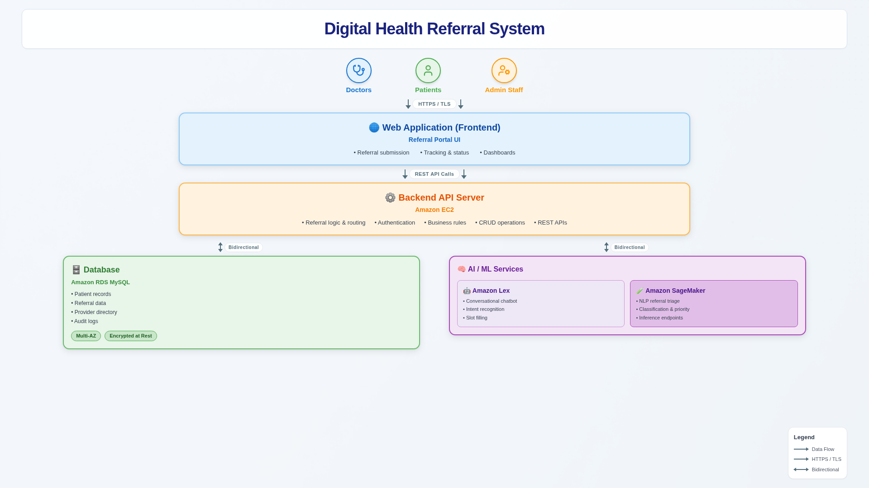
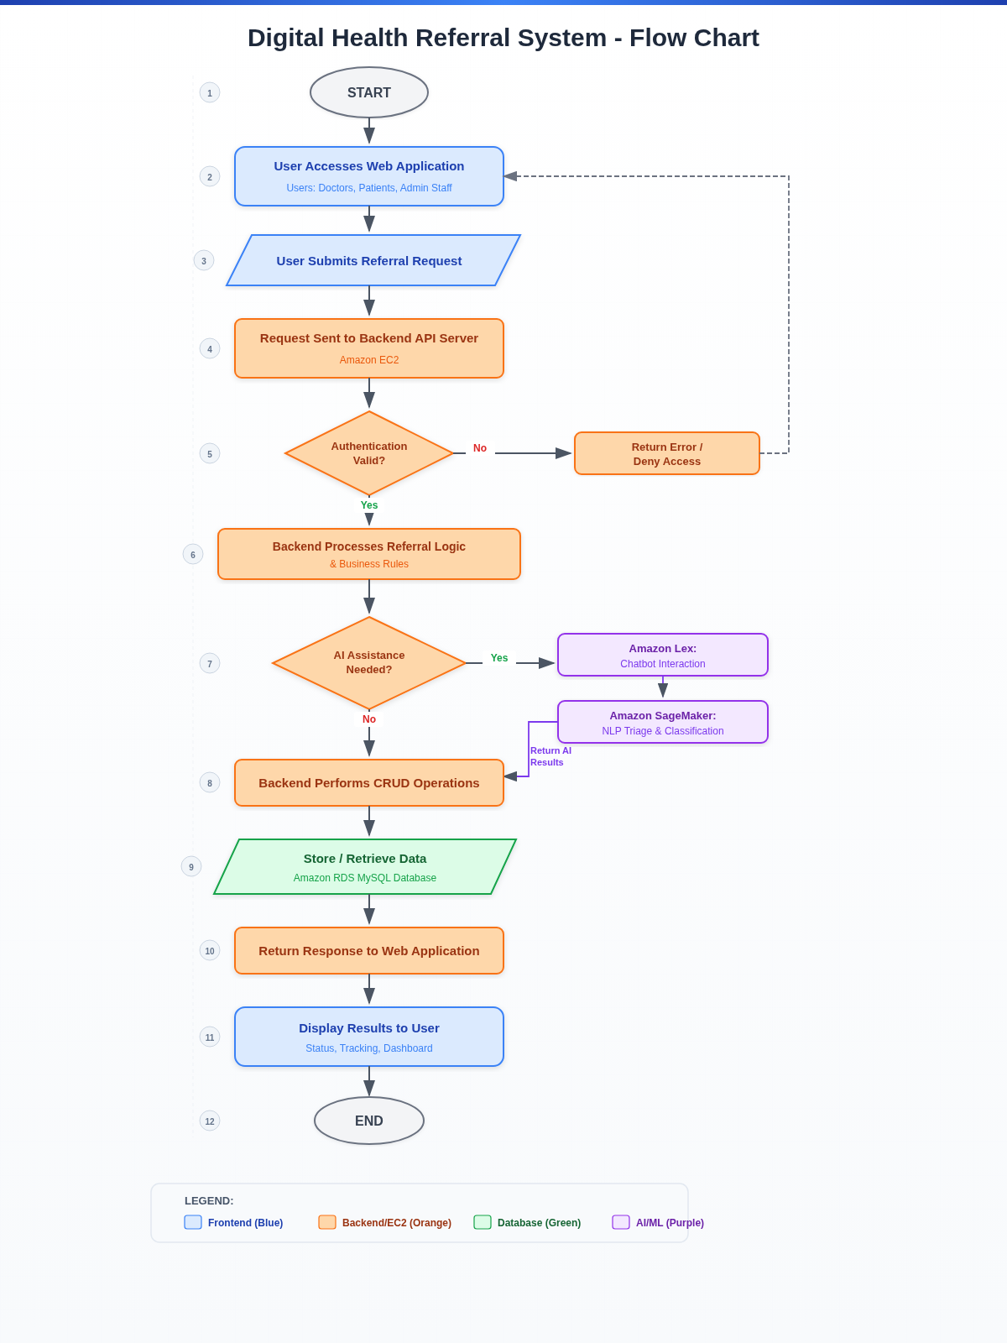
- Significance and Expected Outcomes

9.1 Significance of the Research

This research is important because it addresses inefficiencies in South Africa’s public healthcare system, where referral management and patient records are often fragmented or paper-based. By introducing a centralized digital solution, the project improves coordination between healthcare facilities, supports continuity of care, and reduces lost or delayed referrals, leading to better patient outcomes.
The study also highlights how cloud computing and artificial intelligence can provide scalable, cost-effective digital health solutions in low-resource environments. In addition, replacing informal communication methods with a structured system improves data security, accountability, and traceability within healthcare settings.

9.2 Performance Improvement
The proposed system is expected to deliver measurable improvements in key performance areas:
    - Reduction in referral processing time:
Real-time tracking and digital workflows will significantly reduce delays compared to manual or paper-based systems.
    - Improved efficiency:
Automation of administrative tasks (e.g., referral creation, record retrieval) will reduce workload and improve productivity.
    - Enhanced data accuracy:
Centralized data storage reduces duplication and minimizes errors associated with manual record handling.
    - Improved communication:
A unified platform ensures consistent and structured communication between healthcare providers.
    - Faster decision-making:
Immediate access to complete patient records supports better clinical decisions.
These improvements will be evaluated using measurable indicators such as task completion time, system response time, and referral completion rates.

9.3 Expected Deliverables (Prototype / Model)
The primary outcome of this project will be a functional prototype of a digital healthcare system that demonstrates the feasibility and effectiveness of the proposed solution.

The prototype will include:
    - Web-Based Application
    - User interface for healthcare professionals
    - Secure login and role-based access
    - Patient Record Management Module
    - Create, store, and retrieve patient information
    - Centralized database using MySQL
    - Referral Tracking Module
    - Create, assign, and monitor referrals
    - Real-time status updates
    - AI Chatbot Integration
    - Natural language interaction
    - Support for tasks such as retrieving records and checking referral status
    - Cloud-Based Deployment
    - Hosted on a cloud platform
    - Demonstrates scalability and accessibility

9.4 Validation of the Prototype
The prototype will be evaluated to demonstrate its effectiveness through:
    - Performance testing (response time, efficiency)
    - User testing (ease of use and usability)
    - Comparative analysis (manual vs digital system)
This ensures that the system is not only functional but also meets the objectives of improving referral tracking and system efficiency.

9.5 Industry and Societal Impact
The proposed system has the potential to support the digital transformation of healthcare systems in South Africa and similar environments. By improving efficiency and reducing delays, the system can contribute to better patient care and more effective use of healthcare resources.
In the long term, the solution can be expanded and adapted for broader implementation across multiple healthcare facilities, supporting national healthcare improvement initiatives.
- Project Plan and Timeline

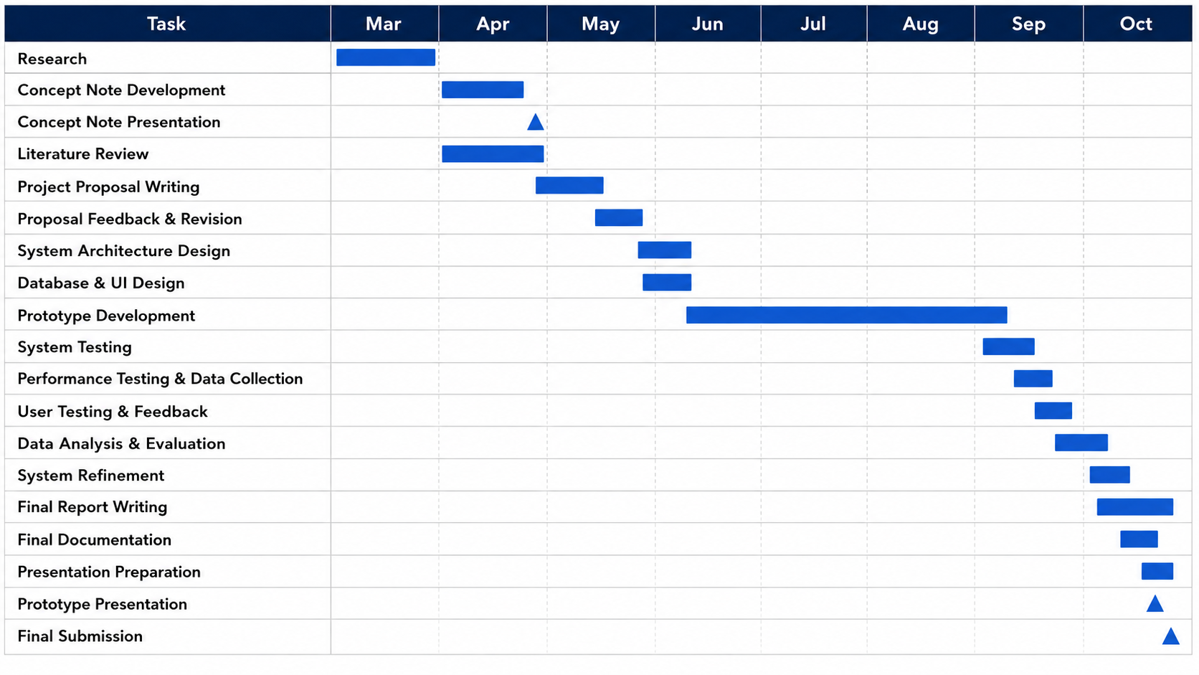
- Budget Estimate

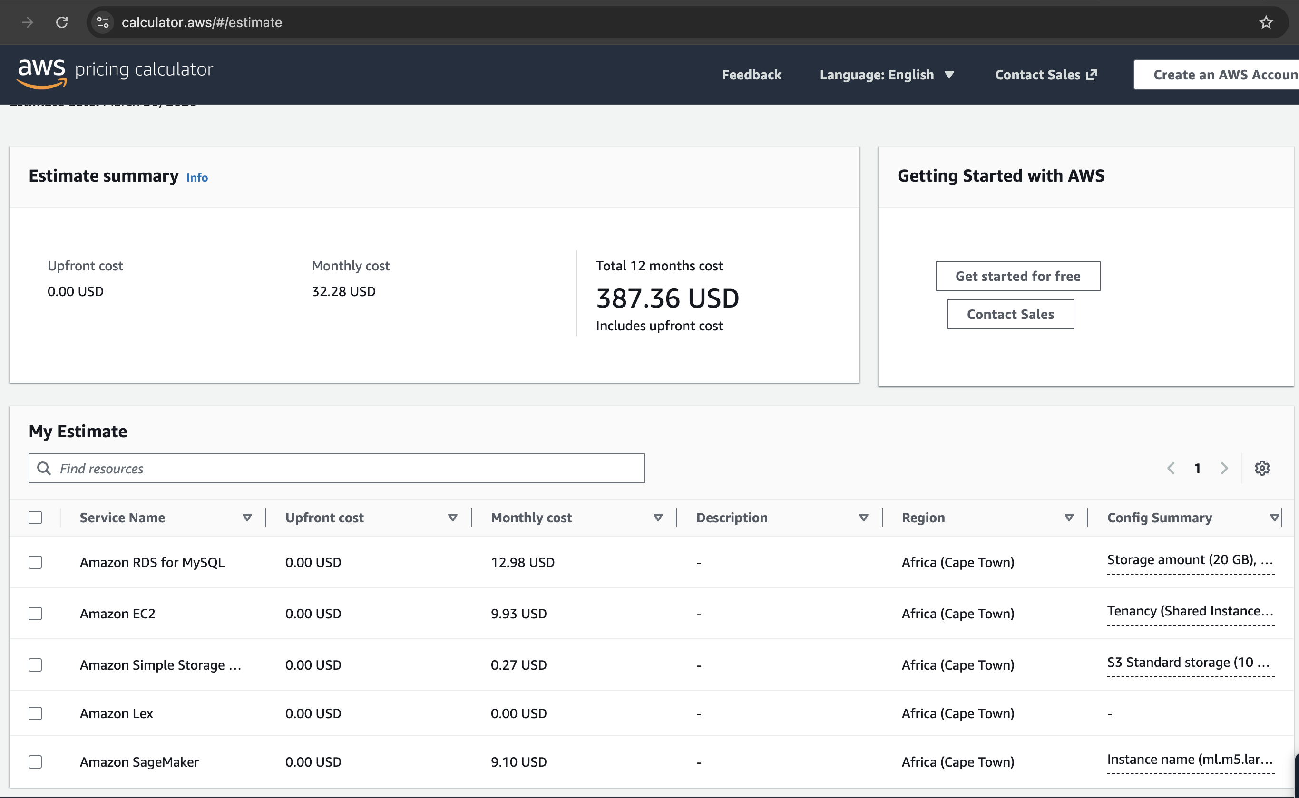
- Delimitations & Limitations

Delimitations:
- Focus on web-based system only
- Limited to core features (records + referrals + chatbot)

Limitations:
- Internet dependency
- Limited real-world deployment testing
- AI chatbot accuracy constraints
- Risk Assessment

Risk | Impact | Mitigation
System downtime | High | Use reliable cloud services
Data security breach | High | Implement encryption & authentication
Poor user adoption | Medium | Design user-friendly interface
AI errors | Medium | Limit chatbot to non-critical tasks

- Conclusion

This project addresses critical challenges in healthcare systems by proposing a scalable, secure, and integrated digital solution. By combining cloud computing and artificial intelligence, the system aims to improve referral tracking, enhance communication, and support better patient outcomes in resource-constrained environments.
- References

- S. J. Hysong et al., “Towards successful coordination of electronic health record based-referrals,” Implementation Science, 2011.
- BMC Medical Informatics, “Improving the effectiveness of electronic health record-based referral processes,” 2012.
- A. Azamar-Alonso et al., “Electronic referral systems in health care: a scoping review,” 2019.
- A. Bompelli et al., “AI and EHR systems: A scoping review,” 2021.

